**LOGO CREATION STEPS :**

**STEP 1 – DOWNLOAD AND LOGIN IN CANVA APP**

**SEARCH – LOGO CREATION FOR RESTAURANT**

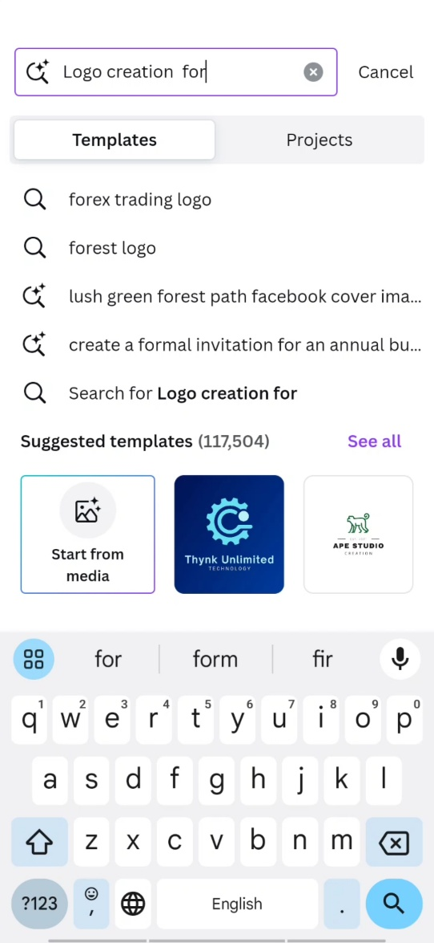

**STEP 2 :**

**Select or Create according to Your design**

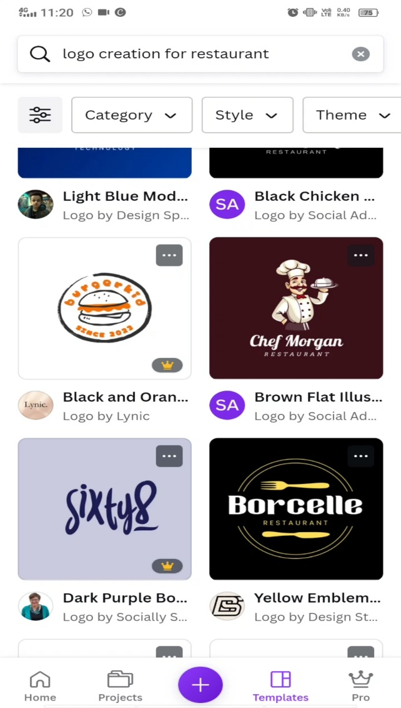

**STEP 3 :**

**Edit as – “ YOUR BRAND NAME - ELNINO**

